Blizzard Builder

Testing and Validation

Hayden Streib

Final Project

Since this program is limiting the user by only giving them predetermined choices, we can validate this program with only a few examples.

By design, the user cannot continue to the next window unless they click on the *Next* button, leaving them with only two options, select something, or don’t. If the user fails to select one of the predetermined choices, the *Next* button will trigger a warning pop up*(fig.1)*. The toppings window has a *Complete your Order* button and it works the same way. The list box featured in the toppings window allows the user to select or deselect their topping(s) of choice.

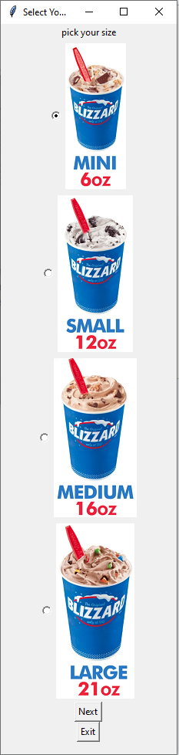

**Data Test**

Data set

**Size:** Mini

**Soft Serve Flavor:** Twist

**Toppings:** Reeses and Hot Caramel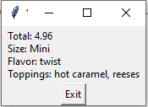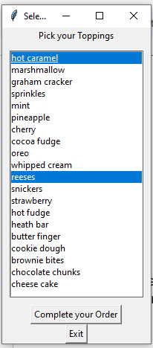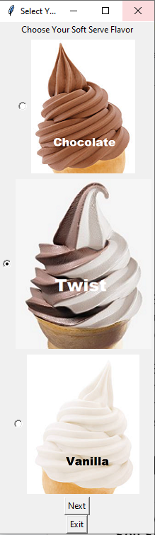

*(fig.1)* 